

REPORT ON

FOUR WEEKS OF INTERNSHIP

Carried out at

# SMARTBRIDGE EDUCATIONAL SERVICES PVT. LTD

*Submitted to*

## NMAM INSTITUTE OF TECHNOLOGY, NITTE

(An Autonomous Institution under VTU, Belagavi)

*In partial fulfillment of the requirements for the award of the*

Degree of Bachelor of Engineering in

Computer Science & Engineering

*By*

**JASMINE GLANI MATHIAS**

USN: **4NM17CS070**

Under the guidance of

**Mr. JAYAPRAKASH. CH**

Program Manager



CERTIFICATE

*This is to certify that the “Internship report” submitted by* ***Ms. Jasmine***

***Glani Mathias*** *bearing* ***USN 4NM17CS070*** *of 8th semester B.E., a bonafide student of NMAM Institute of Technology, Nitte, has undergone at least four weeks of internship at* ***SmartBridge Educational Services Pvt. Ltd*** *during May 2020 fulfilling the partial requirements for the award of degree of Bachelor of Engineering in* ***Computer Science & Engineering*** *at NMAM Institute of Technology, Nitte****.***

*Name and Signature of Mentor Signature of HOD*

# INDUSTRY CERTIFICATE

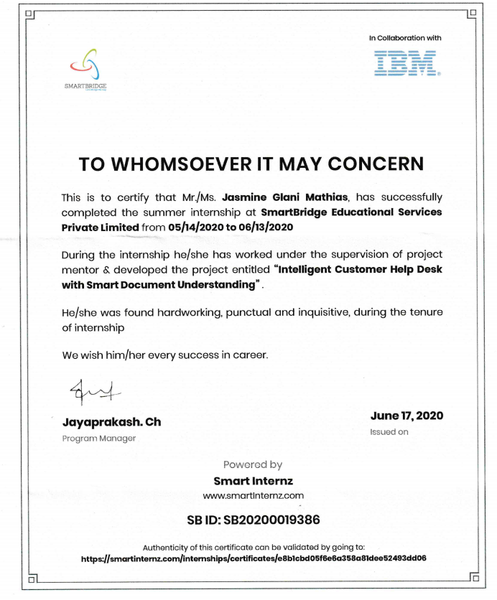

# ACKNOWLEDGEMENT

I take this opportunity to express my heartfelt gratitude and appreciation to all those who provided me the support and encouragement to complete these projects. Without their contributions, inputs and suggestions, I would not have succeeded in developing the idea and completing the project. I record my indebtedness to SMARTBRIDGE EDUCATIONAL SERVICES PVT.LTD for giving me a platform to learn during my internship.

My heartfelt thanks to my esteemed guide and mentor, **Mr. Jayaprakash. Ch,** Program Manager at SMARTBRIDGE EDUCATIONAL SERVICES PVT. LTD, for his valuable advice, endless support and motivation, constantly throughout.

I would like to thank **Dr. Niranjan Chiplunkar**, Principal, NMAMIT and the Department of Computer Science and Engineering for their consistent support and providing me this opportunity to do the internship.

I would like to thank **Dr. Jyothi Shetty**, Head of Department, Department of Computer Science and Engineering for their constant support and providing me this opportunity to do the internship.

I would like to thank my guide **Mr. Sandeep Kumar Hegde**, Associate Professor Gd II, Department of CSE for all the support and guidance.

I would like to thank SMARTBRIDGE EDUCATIONAL SERVICES PVT.LTD for providing me with the necessary facilities for carrying out the work.

Finally, I would like to thank everyone who has directly or indirectly contributed to the internship.

**Jasmine Glani Mathias**

**(4NM17CS070)**

## TABLE OF CONTENTS

**CONTENT PAGE NUMBER**

TITLE PAGE… I

INSTITUTE CERTIFICATE… II

INDUSTRY CERTIFICATE… III

ACKNOWLEDGEMENT IV

TABLE OF CONTENTS V

LIST OF FIGURES VI

1. ABSTRACT 1
2. INTRODUCTION TO THE INDUSTRY 2
3. DETAILS OF THE TRAINING UNDERGONE 3
   1. Introduction 3
   2. Problem Statement 3
   3. Objective 3
   4. Theoretical Analysis 4
   5. Methodology 5-6
   6. Results 7-8
4. CONCLUSION 9
5. [REFERENCES](https://docs.google.com/document/d/1l31_eMUlVzMZn4m2JkeaVhhSg0hR-OJEW5WnwEpHfTQ/edit#heading%3Dh.z337ya) [1](https://docs.google.com/document/d/1l31_eMUlVzMZn4m2JkeaVhhSg0hR-OJEW5WnwEpHfTQ/edit#heading%3Dh.z337ya)0

## 

## LIST OF FIGURES

Figure 3.4.1 Flow Diagram of Customer Care Chatbot………………………………………4

Figure 3.5.1 Node Red Flow…………………………………………………………………….6

Figure 3.6.1 Customer Care Chatbot(Greeting) ………………………………………...……7

Figure 3.6.2 Customer Care Chatbot(What can you do)…………………………………….7

Figure 3.6.3 Customer Care Chatbot(What does blue indicate-operation of device)….....8

Figure 3.6.4 Customer Care Chatbot(Operation of a device)……………………………….8

**1. ABSTRACT**

SmartBridge is an EdTech organization with a vision to bridge the gap between academia & industry. It provides outcome-based experiential learning programs on emerging technologies (Internet of Things, Machine Learning, Data Science, Artificial Intelligence, Robotics) building skilled entry - level engineers, for the corporate world. SmartBridge is in mission to build technology communities in academia to encourage students towards innovation & entrepreneurship.

I have done my internship on Artificial Intelligence using IBM Cloud which helped me to understand the concepts of multiple Watson services like Watson Assistant, Watson Discovery, Watson Cloud Functions and Node-RED and learnt about how, why and where to use them.

The objective of the internship was to develop an Intelligent Customer Helpdesk with Smart Document Understanding Chatbot which will efficiently answer all the query of customer with its smart document understanding ability and guide toward the solution of the problem. Through this internship, I got a firm grasp on developing chatbots and explore the different elements of IBM Cloud on developing web apps.

The training focused heavily on commercial aspects of web apps such as the usage of Watson services and when to use them as well as what makes for an appealing user interface. By learning the trips and tricks that industries use to expand their user base, I learnt ways to make myself more useful and appealing as a prospective employee to different industries.



## 

## 2. INTRODUCTION TO THE INDUSTRY

THE SMARTBRIDGE is a comprehensive one-stop platform catering to the skill & knowledge development of the young graduates turning professionals. They are building the Next-Gen Talent pool with skills in emerging technologies i.e., Artificial Intelligence, Data Science, Internet of Things (IoT), Robotics, Blockchain, Quantum Computing and Cyber Security. Their unique models of project-based learning, micro- skilling and internships helps students in building their competency & get ready for industry. inception, they have trained thousands of students, faculty and working professionals on emerging technologies via technical bootcamps, hackathons, Summer & Winter Internship Programs.

SmartInternz is an Experiential learning & Remote Internship Platform to bring academia & industry very close for a common goal of talent creation. They bring the students, educators and employers on a common platform to fill the gap between academia & industry.

## 3. DETAILS OF THE TRAINING UNDERGONE

**3.1 INTRODUCTION**

For businesses, it has become necessary to solve the queries and problems of the customers to ensure consumer loyalty along with the brand establishment. In our regular customer support team, there are many problems such as: Generally live agents can handle only one conversation at a time, if our business receives a lot of inquires (may be many queries can be similar), then we’d also need large customer support team 24x7 support staff may need breaks. They can’t work 24 hours a day. But a chatbot doesn’t need any breaks.

**3.2 PROBLEM STATEMENT**

The typical customer care chatbot can answer simple questions, such as store locations and hours, directions, and maybe even making appointments. When a question falls outside of the scope of the pre- determined question set, the option is typically to tell the customer the question isn’t valid or offer to speak to a real person.

**3.3 OBJECTIVE**

The purpose of the project is to make the chat with customer in more effective way. This project aims to solve the major customer problem without any human interaction with its power of understanding the language and also the document to provide the detail solution of the customer problem. The project shall use the Smart Document Understanding feature of Watson Discovery to train it on what text in the owner’s manual is important and what is not. This will improve the answers returned from the queries. This chatbot will efficiently answer all the query of customer with its smart document understanding ability and guide toward the solution of the problem.

### 

### 3.4 THEORETICAL ANALYSIS

Flow diagram for Customer Care Chatbot is shown in figure 3.4.1

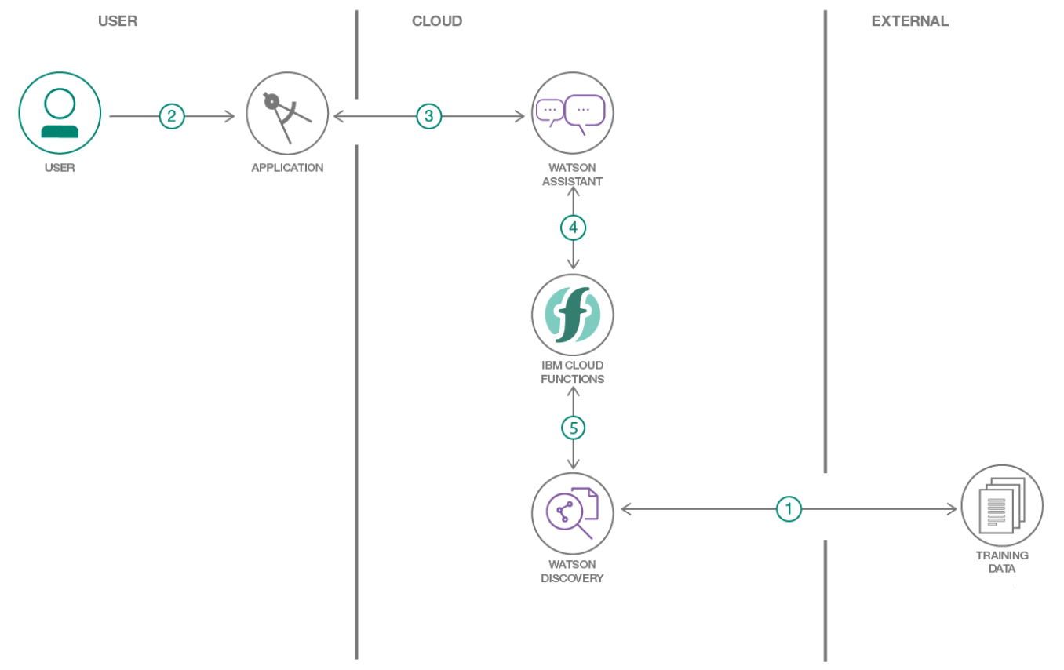

*Figure 3.4.1: Flow diagram of Customer Care Chabot*

* The document is annotated using Watson Discovery Smart Document Understanding.
* The user interacts with the back-end server via the app UI. The front-end app UI is a chatbot that engages the user in a conversation.
* Dialog between the user and back-end server is coordinated using a Watson Assistant dialog skill.
* If the user asks a product operation question, a search query is passed to a predefined IBM Cloud Functions action.
* The IBM Cloud Functions action will query the Watson Discovery Service and return the results.

### 3.5 METHODOLOGY

The steps involved in the project are

1. Create IBM Cloud services

The following services were created on the IBM Cloud platform.

* + Watson Discovery
  + Watson Assistant
  + Node Red

1. Configure Watson Discovery

* Import the document

The Data Collection is taken from the below link:

https://usermanual.wiki/Document/ecobee3userguide.988047616/view

Launch the Watson Discovery tool and create a new data collection by selecting the Upload your own data option. Give the data collection a unique name. When prompted, select and upload the ownersmanual.pdf file located in the data directory of your local repository.

# Annotate with SDU

Apply SDU to the document to see if it can generate some better query responses. The goal is to annotate all the pages in the document so that Watson Discovery can learn what text is important, and what text can be ignored.

1. Create IBM Cloud Functions action

Create the web action that will make queries against our Discovery collection. The code simply connects to the Discovery service, makes a query against the collection, then returns the response.

1. Configure Watson Assistant

Launch the Watson Assistant tool and create a new dialog skill. Select the Use sample skill option as your starting point. This dialog skill contains all of the nodes needed to have a typical call center conversation with a user.

* Add new intent

Create a new intent that can detect when the user is asking about operating the Product.

* Create new dialog node

Add a node to handle our intent. Name the node "Ask about product" and assign it our new intent. This means that if Watson Assistant recognizes a user input such as "how do I set the time?" it will direct the conversation to this node.

* Enable webhook from Assistant

Set up access to our Webhook for the IBM Cloud Functions action.

1. Create a Node-RED flow to connect all the services together, deploy and run Node-RED app

Create the Node-RED flow using the Debug node which displays messages in the sidebar,Function node can be used to write custom JavaScript to run against messages, ui_Form, ui_Text, ui_Button and Assistant. At this point, the nodes only exist in the editor and must be deployed to the server. Web based UI was developed by integrating all the services using Node red. After deploying, run the Node-RED app.

Flow diagram for Node-RED is shown in figure 3.5.1.

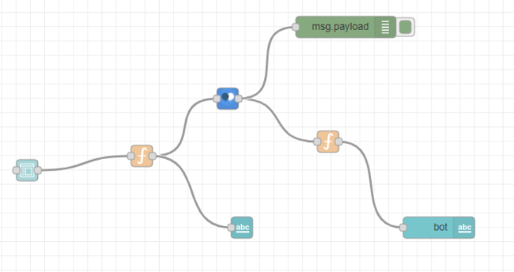

*Figure 3.5.1: Node Red Flow*

## 

## 3.6 RESULTS

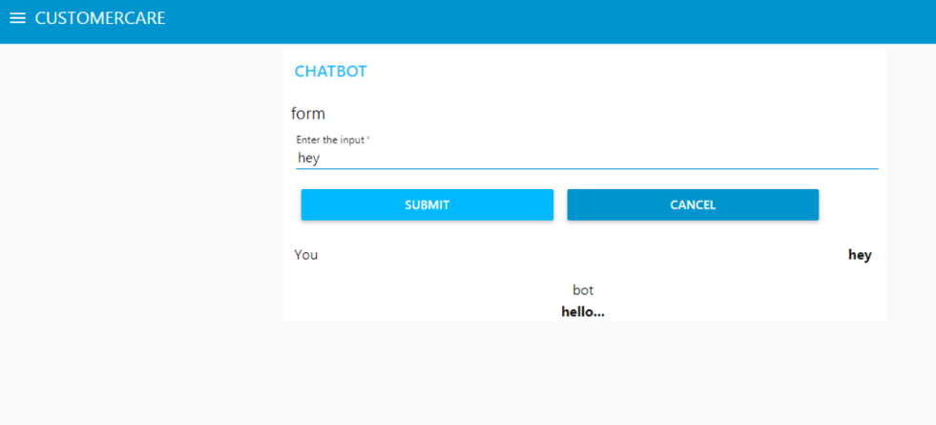

*Figure 3.6.1: Customer Care Chatbot(Greeting)*

As seen from figure 3.6.1, the typical customer care chatbot consist of input field where the customer can type the queries and click on submit button and the bot returns the results. As the customer enters hey, the bot greets the customer with suitable greetings such as hello.

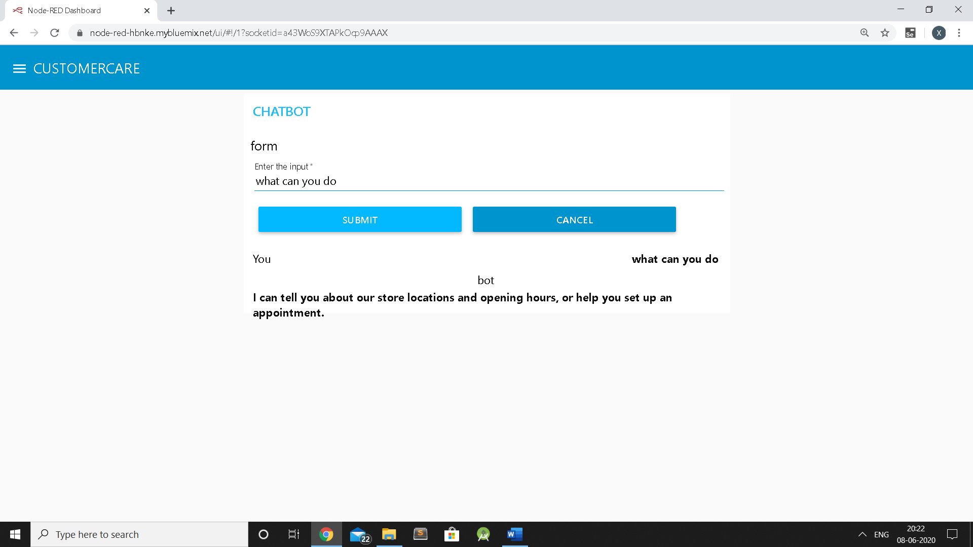

*Figure 3.6.2: Customer Care Chatbot(What can you do)*

As seen from figure 3.6.2, the typical customer care chatbot can answer simple questions, such as store locations and hours, directions, and maybe even making appointments.

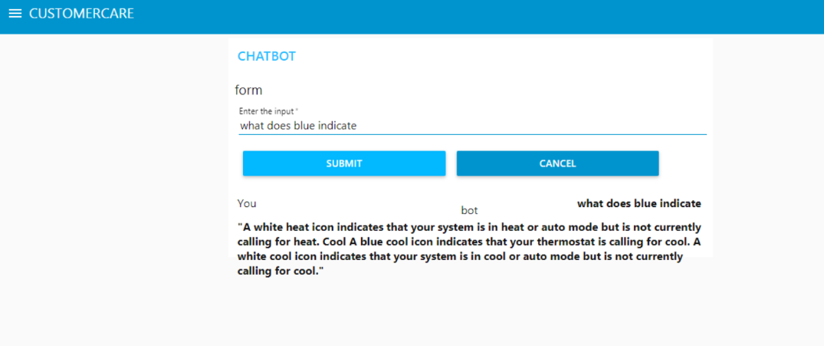

*Figure 3.6.3: Customer Care Chatbot(What does blue indicate-Operation of device)*

As seen from figure 3.6.3, As the customer asks what does blue indicate, the

bot replies with accurate answers which are relevant to the query.

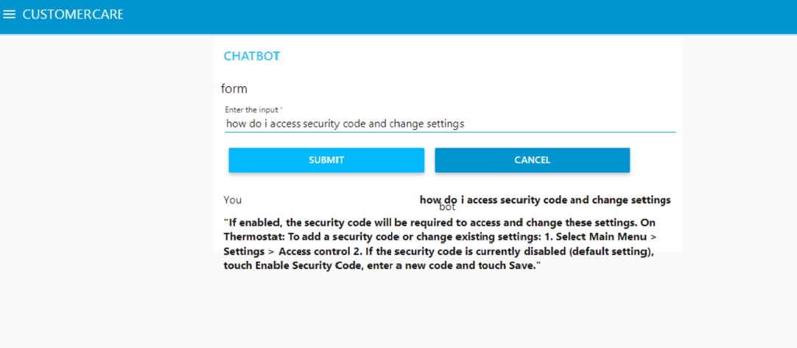

*Figure 3.6.4: Customer Care Chatbot(Operation of a device)*

As seen from figure 3.6.4, Since the customer’s question is about the operation of a device, the application shall pass the question onto Watson Discovery Service, which has been pre-loaded with the device’s owner’s manual and returns relevant answers to solve the customer’s problem.

## 4. CONCLUSION

I have worked on developing Intelligent Customer Helpdesk with Smart Document Understanding Chatbot and came out more experienced as an Artificial Intelligence Developer. Chatbots are quickly making transformational changes and allowing businesses to thrive through customer interactions. Use of conversational AI chatbots only means better engagement and relentless need for customer satisfaction in the near future. The 4 weeks of internship also gave me insight into little tips and tricks they use to become more successful.

I have come out of internship more confident in myself and would like thank SMARTBRIDGE EDUCATIONAL SERVICES PVT.LTD for letting me into their platform for this amazing experience.

## 5.REFERENCES

1. <https://developer.ibm.com/tutorials/how-to-create-a-node-red-starter-applicat>[ion/](https://developer.ibm.com/tutorials/how-to-create-a-node-red-starter-application/)
2. <https://developer.ibm.com/components/watson-assistant/>
3. <https://developer.ibm.com/articles/introduction-> [watson-discovery/](https://developer.ibm.com/articles/introduction-watson-discovery/)
4. <https://www.ibm.com/watson/how-to-build-a-chatbot>
5. <https://usermanual.wiki/Document/ecobee3userguide.988047616/view>
6. <https://www.thesmartbridge.com/>